Chapter 6: Recognising C Code Constructs in Assembley

Introduction
This manual explains how common C programming constructs appear after compilation into assembly language. The practical exercises demonstrate how programs can be analysed using IDA Pro after compiling C source code with GCC.
The chapter focuses on:
- Global and local variables
- Arithmetic operations
- If statements
- Nested if statements
- Loops
- Function call conventions
- Switch statements
- Arrays
- Graph analysis in IDA Pro
The exercises are designed to strengthen reverse engineering and malware analysis skills by helping students recognise common assembly patterns generated by C programs.

Setting Up the Lab Environment Using Dev-C++

Objective
The purpose of this practical exercise is to understand how global and local variables are represented in assembly language after a C program is compiled. The exercise also introduces the process of compiling C programs and analysing executables in IDA Pro.
Before analysing assembly code in IDA Pro, a small lab environment was prepared to allow C programs to be written, compiled, executed, and reverse engineered.
The lab environment consisted of:
- Windows 10 Virtual Machine
- Dev-C++
- GCC Compiler (included with Dev-C++)
- IDA Free / IDA Pro

Installing Dev-C++
Dev-C++ was used as the code editor and compiler environment for writing, compiling, and running C programs.
Dev-C++ includes the GCC compiler, which means a separate compiler installation is usually not required.
Dev-C++ can be downloaded from:
Embarcadero Dev-C++ Download
After downloading:
- Run the installer
- Follow the installation steps
- Select the default GCC compiler package during installation
- Complete the setup
Once installed, Dev-C++ provides:
- C/C++ code editing
- Syntax highlighting
- Built-in GCC compiler
- Program compilation and execution
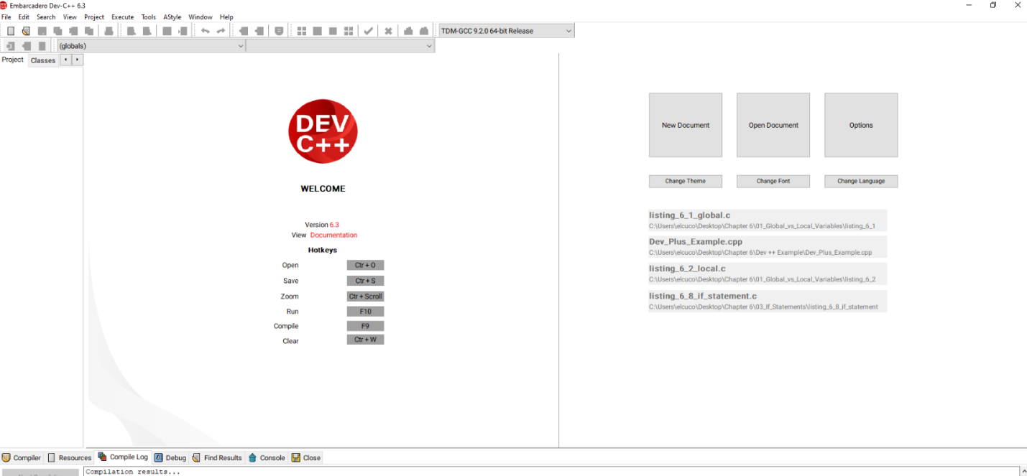
- Debugging support

Verifying the Compiler Installation
To verify that the GCC compiler is working correctly:
- Open Dev-C++
- Create a new source file
- Type the following program:
#include <stdio.h>
int main()
{
printf("Compiler working successfully!\n");
return 0;
}
- Save the file
- Press:
F11 or select: Execute → Compile & Run
If the program runs successfully, the compiler is correctly installed.
Dev-C++ automatically generates the executable (.exe) file in the project folder.
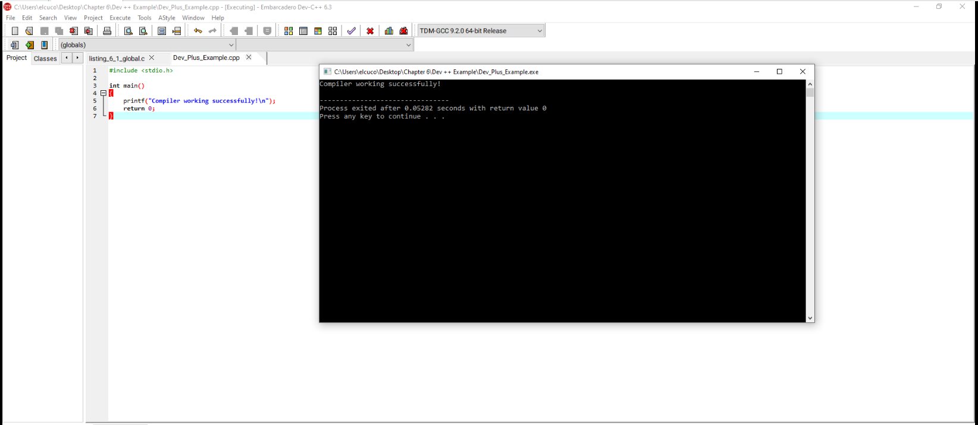

Installing IDA Free / IDA Pro
IDA Free / IDA Pro was used for static analysis and disassembly of executable files.
IDA converts machine code into assembly language instructions, allowing analysis of:
- Variables
- Memory usage
- Arithmetic operations
- Function calls
- Stack operations
IDA Free can be downloaded from:
https://hex-rays.com/
After installation, the compiled executable files were opened in IDA for reverse engineering and assembly analysis.

Global vs Local Variables

Create the Source Code File

- Create the following folder structure on the Desktop:
Chapter 6
└── 01_Global_vs_Local_Variables
└── listing_6_1_global

- Launch Visual Studio Code or a text editor of your choice.
Inside the folder, create a new file named:
  - Listing_6_1_global.c
Type the following C program exactly as shown below:

#include <stdio.h>

int x = 1;
int y = 2;

int main()
{
x = x + y;
printf("total = %d\n", x);
return 0;
}

What this means
x and y are global variables because they are declared outside main().
They start as:
x = 1
y = 2
Then this line runs:
x = x + y;
So: x = 1 + 2
x = 3

Then this prints: printf("total = %d\n", x);
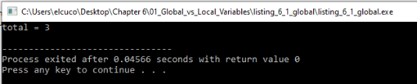
Output: total = 3

Your IDA assembly
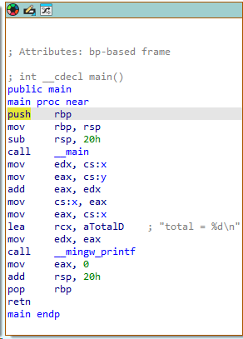

Focus only on these important lines:
mov edx, cs:x
mov eax, cs:y
add eax, edx
mov cs:x, eax
mov eax, cs:x
lea rcx, aTotalD
mov edx, eax
call __mingw_printf

Explanation
In this example, x and y are global variables because they are declared outside the main function. In the assembly code, IDA references them directly as cs:x and cs:y.
This shows that the variables are stored in a fixed memory location, not on the stack.

The instruction mov edx, cs:x loads the value of x into edx. Since x is 1, edx becomes 1. The instruction mov eax, cs:y loads the value of y into eax. Since y is 2, eax becomes 2.

The instruction add eax, edx adds the two values together. After this instruction, eax contains 3.
The instruction mov cs:x, eax stores the result back into the global variable x. This means x has now changed from 1 to 3 in memory.

The next instructions prepare the printf function. The string “total = %d\n” is loaded, and the updated value of x is passed to printf. The call __mingw_printf instruction then prints the result on the screen.

Your key point
The important observation is that global variables are referenced directly by memory names such as cs:x and cs:y. This is different from local variables, which are referenced using stack offsets such as [rbp-4].

Local Variables in Assembly Language

Create the Source Code File
- Create the following folder structure on the Desktop:
Chapter 6
└── 01_Global_vs_Local_Variables
└── listing_6_2_local
- Launch Visual Studio Code or a text editor of your choice.
Inside the folder, create a new file named:
Listing_6_2_local.c
Type the following C program exactly as shown below:
#include <stdio.h>
int main()
{
int x = 1;
int y = 2;
x = x + y;
printf("total = %d\n", x);
return 0;
}

What this means
x and y are local variables because they are declared inside main().
They start as: x = 1 y = 2
Then this line runs: x = x + y;
So: x = 1 + 2
x = 3
Then this prints: printf("total = %d\n", x);
Output: total = 3
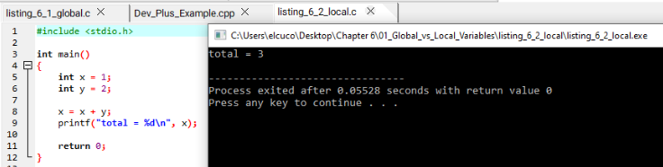

Your IDA Assembly
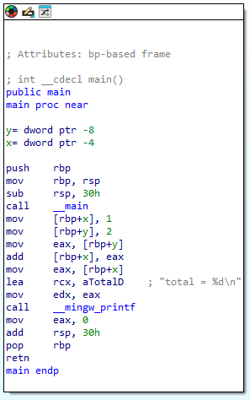
Focus only on these important lines:
mov [rbp+x], 1
mov [rbp+y], 2
mov eax, [rbp+y]
add [rbp+x], eax
mov eax, [rbp+x]
lea rcx, aTotalD
mov edx, eax
call __mingw_printf
IDA also identifies the local variables as:
y = dword ptr -8
x = dword ptr -4

4. Explanation
In this example, x and y are local variables because they are declared inside the main() function. Unlike global variables, they are not referenced directly by memory names such as cs:x or cs:y.
Instead, the variables are stored on the stack and referenced using rbp-relative offsets.
The instruction: mov [rbp+x], 1
stores the value 1 into the local variable x.
The instruction:
mov [rbp+y], 2 stores the value 2 into the local variable y.
The instruction: mov eax, [rbp+y] loads the value of y into eax. Since y is 2, eax becomes 2.
The instruction: add [rbp+x], eax adds the value stored in eax to the local variable x.
After this instruction: x = 3
The instruction: mov eax, [rbp+x]
loads the updated value of x into eax so it can be passed to printf.
The next instructions prepare the printf function. The string "total = %d\n" is loaded, and the updated value of x is passed to printf.
The instruction:
call __mingw_printf then prints the result on the screen.

Your key point
The important observation is that local variables are referenced using stack offsets such as:
[rbp+x]
[rbp+y]
rather than direct memory references such as:
cs:x
This indicates that local variables are stored temporarily on the stack and exist only while the function is executing.

Disassembling Arithmetic Operations

Create the Source Code File
Create the following folder structure on the Desktop:
Chapter 6
└── 02_Arithmetic_Operations
└── listing_6_6_arithmetic

Launch Visual Studio Code or a text editor of your choice.
Inside the folder, create a new file named:
listing_6_6_arithmetic.c

Type the following C program exactly as shown below:
#include <stdio.h>

int main()
{
int a = 0;
int b = 1;

a = a + 11;
a = a - b;
a--;
b++;

b = a % 3;

return 0;
}

What this means
The program creates two local variables:
a = 0
b = 1

The program then performs several arithmetic operations.

Addition
a = a + 11; This increases a by 11.
Result: a = 11

Subtraction
a = a - b; This subtracts b from a.
Result: a = 10
because: 11 - 1 = 10

Decrement
a--; This decreases a by 1. Result: a = 9

Increment
b++; This increases b by 1. Result: b = 2

Modulo Operation
b = a % 3; The % operator performs modulus division.
It stores the remainder after division. Since: 9 % 3 = 0
Result: b = 0

3. Your IDA Assembly
Focus only on these important lines:
mov [rbp+a], 0
mov [rbp+b], 1

mov eax, [rbp+a]
add eax, 0Bh
mov [rbp+a], eax

mov ecx, [rbp+a]
sub ecx, [rbp+b]
mov [rbp+a], ecx

mov edx, [rbp+a]
sub edx, 1
mov [rbp+a], edx

mov eax, [rbp+b]
add eax, 1
mov [rbp+b], eax

Explanation
In this example, the variables a and b are local variables stored on the stack.
The instruction: mov [rbp+a], 0 initialises the local variable a with the value 0.
The instruction: mov [rbp+b], 1 initialises the local variable b with the value 1.

Addition Operation
The instructions:
mov eax, [rbp+a]
add eax, 0Bh
mov [rbp+a], eax perform the operation: a = a + 11;

The value of a is loaded into eax, 11 is added, and the result is stored back into a.
0Bh is hexadecimal for decimal 11.

Subtraction Operation
The instructions:
mov ecx, [rbp+a]
sub ecx, [rbp+b]
mov [rbp+a], ecx perform the operation: a = a - b;

The value of b is subtracted from a, and the updated result is stored back into a.

Decrement Operation
The instructions:
mov edx, [rbp+a]
sub edx, 1
mov [rbp+a], edx perform the operation: a--;

This decreases a by 1.

Increment Operation
The instructions:
mov eax, [rbp+b]
add eax, 1
mov [rbp+b], eax perform the operation: b++;

This increases b by 1.

5. Your key point
The important observation is that arithmetic operations in C are translated into assembly instructions such as:
add AND sub
The compiler loads values into CPU registers, performs the arithmetic operation, and then stores the updated result back into memory.
This is one of the most common patterns observed during reverse engineering and malware analysis.

Recognising If Statements in Assembly Language

Create the Source Code File
Create the following folder structure on the Desktop:
Chapter 6
└── 03_If_Statements
└── listing_6_8_if_statement
Inside the folder, create a new file named the following:
listing_6_8_if_statement.c
Type the following C program:
#include <stdio.h>
int main()
{
int x = 1;
int y = 2;

if (x == y) {
printf("x equals y.\n");
} else {
printf("x is not equal to y.\n");
}
return 0;
}

Compile and Run it
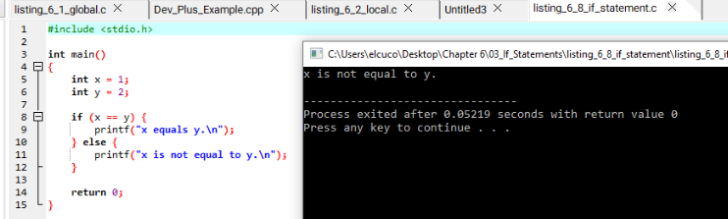

What this means
The program creates two local variables: x = 1 and y = 2
Then it checks this condition: if (x == y)
This means: Is x equal to y?
Since: 1 is not equal to 2
the condition is false.
Therefore, the program executes the else part: printf("x is not equal to y.\n");

3. Your IDA Assembly
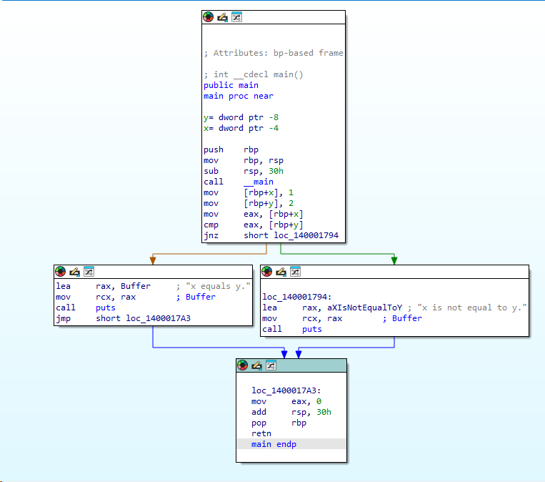

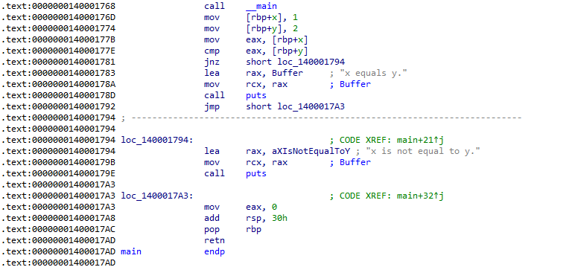

Explanation
In this example, x and y are local variables because they are declared inside the main() function. IDA references them using stack offsets such as [rbp+x] and [rbp+y].
mov eax, [rbp+x] loads the value of x into the register eax.
cmp eax, [rbp+y] compares the value of x with the value of y.
jnz short loc_else means jump if not zero. In this case, it means: If x is not equal to y, jump to the else block.
Since x = 1 and y = 2, the values are not equal. Therefore, the jump is taken, and the program moves to the else section.
The else section then prints: x is not equal to y.

Your key point
The important observation is that an if statement is usually recognised in assembly by:
cmp conditional jump
For example:
cmp eax, [rbp+y]
jnz short loc_else
This shows that the program is making a decision based on a condition.
In reverse engineering, conditional jumps such as jnz, jz, je, jne, jg, and jl are strong indicators of decision-making logic in a program.

Analyzing Functions Graphically with IDA Pro
IDA Pro provides a graphing feature that helps visualise program execution flow. This feature is useful for recognising program constructs such as:
- if statements
- loops
- function calls
- nested conditions
The graph view allows reverse engineers to follow different execution paths visually instead of reading assembly instructions line by line.

Switching to Graph View in IDA
After opening the function in IDA:
- Place the cursor inside the function
- Press:
Spacebar
IDA will switch from text view to graph view.
Pressing the spacebar again switches back to normal assembly view.

Understanding the Graph View
In the graph view, each block represents a section of assembly instructions.
Arrows between the blocks show the possible execution paths of the program.
In the if statement example, the program has two execution paths:
Path | Meaning
Left path | x equals y.
Right path | x is not equal to y.
The decision is controlled by the conditional jump instruction:
jnz short loc_140001794

Understanding the Conditional Jump
The instruction: cmp eax, [rbp+y] compares the values of x and y.
The next instruction: jnz short loc_140001794 means: Jump if values are NOT equal

Execution Paths

Path 1 — Condition is False
If x equals y:
- the jump is NOT taken
- execution continues downward
This path prints: x equals y.

Path 2 — Condition is True
If x does NOT equal y:
- the jump IS taken
- execution moves to the right-side block
This path prints: x is not equal to y.

Why Graph View Is Important
Graph view simplifies reverse engineering because it:
- visually separates execution paths
- makes conditions easier to recognise
- helps identify loops and nested logic
- speeds up analysis of complex programs
Instead of mentally tracking jumps, the analyst can visually follow the control flow.

Your key point
The important observation is that graph view visually represents conditional execution paths created by instructions such as:
cmp, jnz, jz, je, jne
This makes it easier to recognise decision-making logic during reverse engineering and malware analysis.

Recognising Nested If Statements in Assembly Language

Create the Source Code File
Create the following folder structure on the Desktop:
Chapter 6
└── 04_Nested_If_Statements
└── listing_6_10_nested_if
Inside the folder, create a new file named:
listing_6_10_nested_if.c
Type the following C program exactly as shown below:
#include <stdio.h>

int main()
{
int x = 0;
int y = 1;
int z = 2;

if(x == y){
if(z == 0){
printf("z is zero and x = y.\n");
}else{
printf("z is non-zero and x = y.\n");
}
}else{
if(z == 0){
printf("z zero and x != y.\n");
}else{
printf("z non-zero and x != y.\n");
}
}

return 0;
}

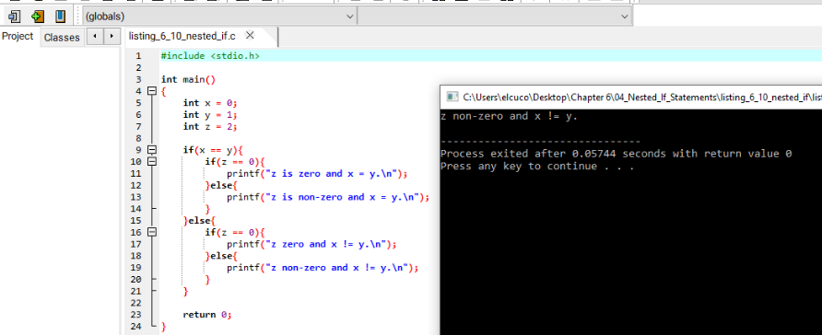
Compile and Run it

What this means
The program creates three local variables:
x = 0
y = 1
z = 2
The program first checks:
if(x == y) Since: 0 != 1
the condition is false.
Execution moves to the else block.
Inside the else block, the program checks:
if(z == 0) Since: z = 2 the condition is also false.
Therefore, the program executes:
printf("z non-zero and x != y.\n");

What to Look for in IDA
When you open the executable in IDA, you will notice:
- multiple cmp instructions
- multiple conditional jumps
- several execution paths in graph view
Important instructions usually include:
cmp
jz
jnz
je
Jne
Nested if statements create:
- multiple decision points
- multiple branches
- more complex control flow graphs

Explanation
In this example, the program contains an if statement inside another if statement. This is called a nested if statement.
The first comparison checks whether: x == y
IDA translates this into:
- a cmp instruction
- followed by a conditional jump
If the condition is false, execution jumps to the outer else block.
Inside each block, another comparison checks whether:
z == 0
This creates another decision point and another conditional jump.
Because nested if statements contain several conditions, the assembly becomes more complex and produces multiple execution paths in IDA graph view.

5. Graph View Observation
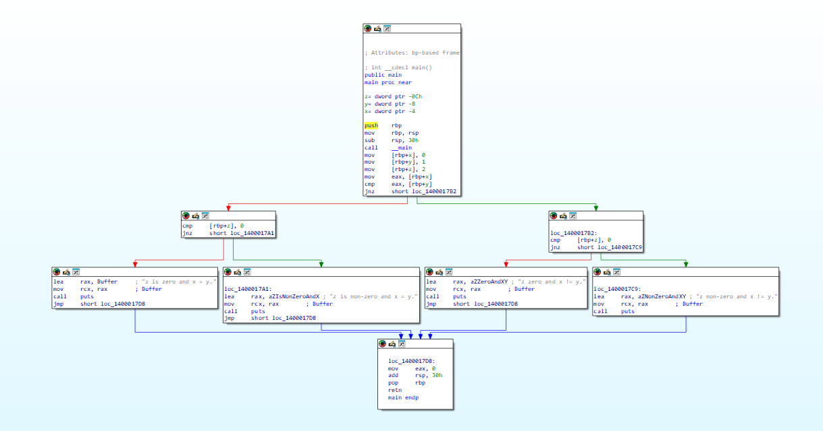
When viewed in IDA graph mode:
- each condition creates a branch
- each branch leads to another decision or output
- the graph becomes larger than a simple if statement
You will notice several connected blocks representing:
- outer if
- inner if
- else sections
- final function exit
This visual structure helps identify nested decision-making logic during reverse engineering.

Your key point
The important observation is that nested if statements create multiple comparison and jump instructions in assembly.
A reverse engineer can recognise nested logic by identifying:
- repeated cmp instructions
- multiple conditional jumps
- several connected branches in graph view
Nested conditions significantly increase the complexity of a program’s control flow.

Recognising Loops in Assembly Language

Finding For Loops
Loops are very common in software and malware analysis. A loop allows a program to repeat instructions multiple times until a condition becomes false.
A for loop normally contains four components:
- initialization
- comparison
- execution instructions
- increment or decrement

Create the Source Code File
Create the following folder structure on the Desktop:
Chapter 6
└── 05_Loops
└── listing_6_12_for_loop
Launch Visual Studio Code or a text editor of your choice.
Inside the folder, create a new file named:
listing_6_12_for_loop.c
Type the following C program exactly as shown below:
#include <stdio.h>

int main()
{
int i;

for(i = 0; i < 100; i++)
{
printf("i equals %d\n", i);
}

return 0;
}

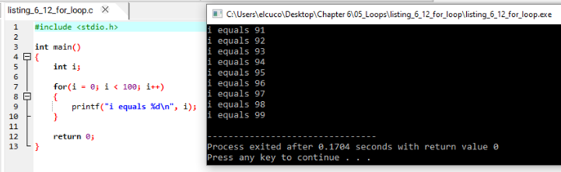
Compile and Run it

What this means
The program creates a local variable: i
The loop starts by setting: i = 0
Then the condition: i < 100 is checked.
If the condition is true:
- the printf statement executes
- i increases by 1
- the condition is checked again
This process repeats until i becomes 100.
At that point:
100 < 100 is false, so the loop stops.

3. What to Look for in IDA
In assembly language, loops are recognised by:
- comparisons
- conditional jumps
- backward jumps
Important instructions usually include:
cmp
jl
jg
jmp
add
inc
A loop normally:
- initializes a variable
- compares it
- executes code
- jumps back to repeat

4. Explanation
The instruction that initializes the loop variable usually looks similar to:
mov [rbp+i], 0
This sets i to 0. The comparison section usually contains:
cmp [rbp+i], 64h
64h is hexadecimal for decimal 100.
This instruction checks whether i is less than 100.
The loop body contains the printf call:
call __mingw_printf
which prints the current value of i.
The increment operation usually appears as:
add [rbp+i], 1
or:
inc [rbp+i]
This increases i by 1 after every iteration.
The important part of a loop is the backward jump instruction. After incrementing i, the program jumps back to the comparison section to repeat the process.

5. Graph View Observation
In IDA graph mode:
- loops appear as circular paths
- one branch returns to an earlier block
- this creates repetition in execution flow
Unlike an if statement, a loop repeatedly revisits the same block of code until the condition becomes false.
This looping structure is easy to recognise visually in graph view.

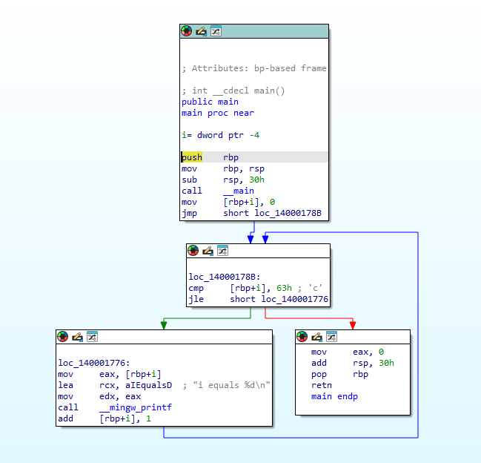

6. Your key point
The important observation is that loops are recognised in assembly by:
- comparisons
- conditional jumps
- backward jumps
A reverse engineer can identify loops by looking for execution paths that return to earlier instructions. This repeated control flow is one of the clearest indicators of looping behaviour in assembly language.

Finding While Loops in Assembly Language

Create the Source Code File
Create the following folder structure on the Desktop:
Chapter 6
└── 06_While_Loops
└── listing_6_14_while_loop
Inside the folder, create a new file named:
listing_6_14_while_loop.c
Type the following C program exactly as shown below:
#include <stdio.h>

int performAction()
{
return 1;
}

int checkResult(int result)
{
return result - 1;
}

int main()
{
int status = 0;
int result = 0;

while(status == 0){
result = performAction();
status = checkResult(result);
}

Compile and Run it
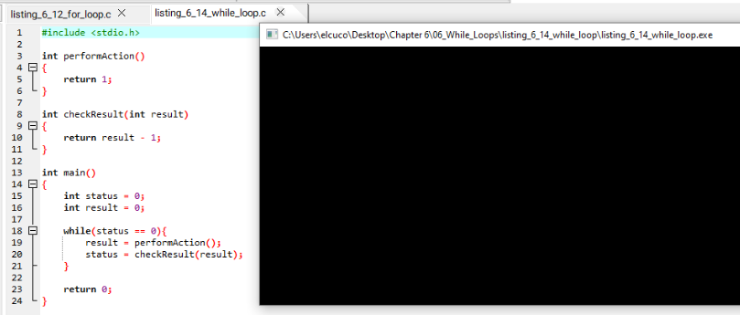

The program finishes silently because nothing is printed.

What this means
The program creates two local variables:
status = 0
result = 0
The loop condition is: while(status == 0)
This means:
- continue looping while status equals 0
Inside the loop:
- performAction() executes
- its return value is stored in result
- checkResult(result) executes
- the returned value is stored in status
The loop continues until:
status != 0
At that point, the condition becomes false and the loop stops.

What to Look for in IDA
In assembly language, a while loop usually contains:
- a comparison
- a conditional jump
- an unconditional backward jump
Important instructions usually include:
cmp
jz
jnz
jmp
call
Unlike a for loop, a while loop normally does not contain a dedicated increment section.

Explanation
The instruction:
mov [rbp+status], 0 initializes the variable status to 0.
The loop condition is translated into a comparison instruction similar to:
cmp [rbp+status], 0
This checks whether status equals 0.
The conditional jump instruction determines whether execution continues inside the loop or exits the loop.
Inside the loop, function calls appear similar to:
call performAction
call checkResult
The result returned from performAction() is stored in result.
The value returned from checkResult(result) is then stored back into status.
At the end of the loop body, the program performs an unconditional jump back to the comparison section to repeat the process.
This repeated backward jump is one of the clearest indicators of looping behaviour in assembly language.

Graph View Observation
In IDA graph mode:
- the comparison block appears near the top
- one branch exits the loop
- another branch continues executing the loop body
- execution then jumps back to the comparison block
This creates a visible cycle in the control flow graph.
Unlike a simple if statement, the execution path repeatedly returns to the same comparison point.
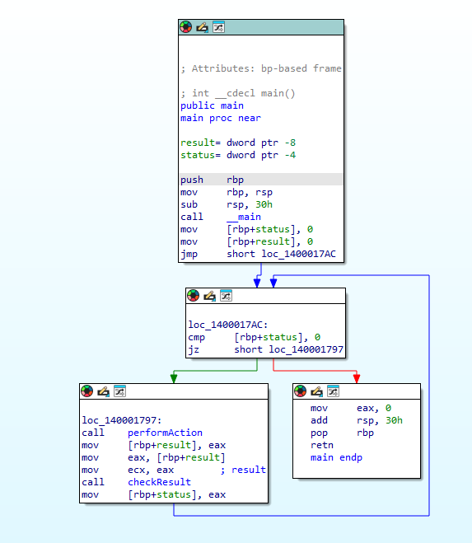

Your key point
The important observation is that while loops are recognised in assembly by:
- a condition check
- conditional jumps
- unconditional backward jumps
A reverse engineer can identify while loops by following execution paths that repeatedly return to the same comparison block until a condition changes.

Understanding Function Call Conventions
Function calls are one of the most important concepts in reverse engineering because programs constantly call functions to perform tasks. Calling conventions define how parameters are passed to functions, where return values are stored, and who is responsible for cleaning the stack after the function finishes executing.
The three common calling conventions encountered in assembly language are:
- cdecl
- stdcall
- fastcall

Create the Source Code File
Create the following folder structure on the Desktop:
Chapter 6
└── 07_Function_Call_Conventions
└── listing_6_16_function_calls
Open Visual Studio Code or a text editor of your choice.
Inside the folder:
listing_6_16_function_calls
create a new file named:
listing_6_16_function_calls.c
Paste the following code exactly as shown below:
#include <stdio.h>

int test(int x, int y, int z)
{
return x + y + z;
}

int main()
{
int a = 1;
int b = 2;
int c = 3;
int ret;

ret = test(a, b, c);

printf("ret = %d\n", ret);

return 0;
}

Compile and Run it

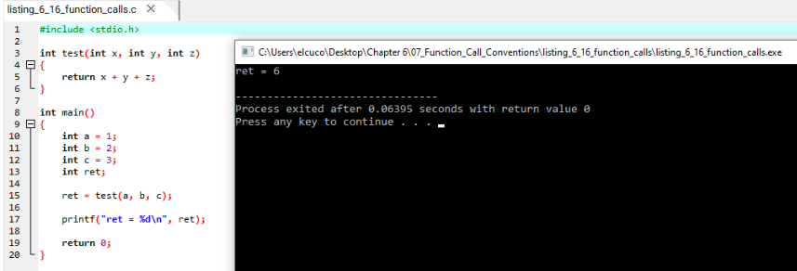

2. What this means
The program creates three variables:
a = 1
b = 2
c = 3
The function call:
ret = test(a, b, c); passes the values into the test() function.
Inside the function, the values are added together:
1 + 2 + 3 = 6
The result is returned and stored in: ret
The program then prints: ret = 6

cdecl Calling Convention
The cdecl calling convention is one of the most common conventions in C programs.
In cdecl:
- parameters are pushed onto the stack from right to left
- the caller cleans the stack
- the return value is stored in eax
Example assembly:
push c
push b
push a
call test
add esp, 12
mov ret, eax
The instruction: add esp, 12 cleans the stack after the function call.
The value 12 represents:
- 3 parameters
- 4 bytes each
- total = 12 bytes

stdcall Calling Convention
The stdcall calling convention is commonly used in the Windows API.
In stdcall:
- parameters are pushed onto the stack from right to left
- the called function cleans the stack
- the return value is stored in eax
Example assembly:
push c
push b
push a
call test
Unlike cdecl, there is no: add esp, 12
after the function call because the callee performs the stack cleanup internally.

fastcall Calling Convention
The fastcall calling convention is designed for faster execution.
Instead of pushing all parameters onto the stack, some parameters are passed using CPU registers.
Example assembly:
mov ecx, a
mov edx, b
push c
call test
In this example:
- a is passed through ecx
- b is passed through edx
- c is pushed onto the stack
Using registers reduces stack operations and improves performance.

Push vs Move
One of the important observations in calling conventions is the difference between push and mov.
The instruction: push eax places data onto the stack.
This is commonly used in:
- cdecl
- stdcall
The instruction:
mov eax, 5 copies data into a register.
This is commonly used in:
- fastcall
because parameters are often passed through registers such as:
- ecx
- edx
instead of the stack.

Your key point
The important observation is that calling conventions determine:
- how parameters are passed
- how functions return values
- who cleans the stack
- how registers are used
A reverse engineer can identify calling conventions by analysing:
- push instructions
- register usage
- stack cleanup instructions
- function calls
- return values stored in eax.

Analyzing Switch Statements in Assembly Language
Switch statements are used to make decisions based on a single value. Depending on the value provided, a different block of code executes.
In assembly language, switch statements are commonly compiled in two ways:
- if-style conditional jumps
- jump tables
This example demonstrates the if-style implementation.

Create the Source Code File
Create the following folder structure on the Desktop:
Chapter 6
└── 08_Switch_Statements
└── listing_6_20_switch_statement
Inside the folder:
listing_6_20_switch_statement
create a new file named:
listing_6_20_switch_statement.c
Paste the following code exactly as shown below:
#include <stdio.h>

int test(int x, int y, int z)
{
return x + y + z;
}
int main()
{
int a = 1;
int b = 2;
int c = 3;
int ret;

ret = test(a, b, c);

printf("ret = %d\n", ret);

return 0;
}

Compile the Program
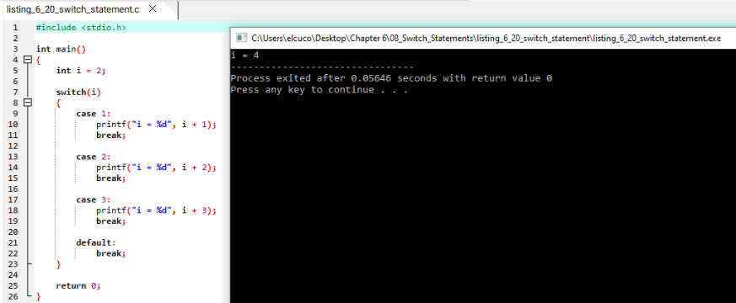

What this means
The program creates a local variable: i = 2
The switch statement checks the value of i.
The program then compares i against each case:
- case 1
- case 2
- case 3
Since: i = 2 the program executes:
printf("i = %d", i + 2);
which prints: i = 4
After executing the selected case, the break statement exits the switch statement.

What to Look for in IDA
In assembly language, switch statements compiled in if-style form usually contain:
- several comparisons
- several conditional jumps
- multiple execution branches
Important instructions usually include:
cmp, jz, jnz, jmp

Explanation
The variable initialization usually appears similar to:
mov [rbp+i], 2
This stores the value 2 into the local variable i.
The switch statement is translated into several comparisons.
Example:
cmp [rbp+i], 1
jz short loc_case1
This checks whether i equals 1.
If not equal, execution continues to the next comparison:
cmp [rbp+i], 2
jz short loc_case2
Since i = 2, this jump is taken.
Execution then moves to the code block for case 2.
Inside that block, the program executes:
add ecx, 2
call printf which performs:
i + 2 and prints the result.
At the end of each case, an unconditional jump instruction skips the remaining cases and moves to the end of the switch statement.

Graph View Observation
In IDA graph mode:
- switch statements create multiple branches
- each case appears as a separate execution path
- all paths eventually merge at the end of the function
This structure makes switch statements easy to recognise visually.
Unlike simple if statements, switch statements usually produce many independent branches

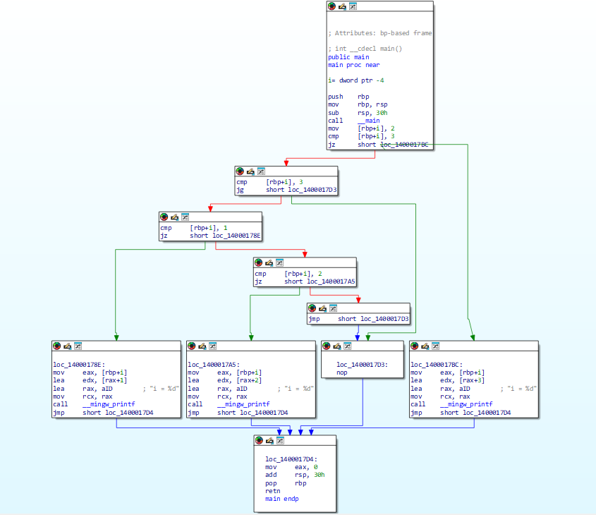

Your key point
The important observation is that switch statements compiled in if-style form are recognised by:
- repeated comparisons
- repeated conditional jumps
- several independent execution branches
A reverse engineer can identify switch logic by observing multiple comparison-and-jump patterns that lead to separate blocks of code.

Switch Statements in Assembly Language
Switch statements are commonly compiled in two ways:
- If Style
- Jump Table
Both methods allow the program to select code execution paths based on a single variable value.

1. If Style Switch Statements
In the if-style method, the compiler converts the switch statement into multiple comparisons and conditional jumps.
This behaves similarly to several if statements connected together.

Example C Code
switch(i)
{
case 1:
printf("i = %d", i + 1);
break;
case 2:
printf("i = %d", i + 2);
break;

case 3:
printf("i = %d", i + 3);
break;
}

Example Assembly
cmp [rbp+i], 1
jz short loc_case1

cmp [rbp+i], 2
jz short loc_case2

cmp [rbp+i], 3
jz short loc_case3

Explanation
The program compares the value of i against each possible case value.
If: i == 1 execution jumps to case 1
If: i == 2 execution jumps to case 2
If: i == 3 execution jumps to case 3
Each comparison uses:
- cmp
- followed by a conditional jump such as:
  - jz
  - je
This approach creates many comparison instructions and many branches.
Characteristics of If Style
Feature | Description
Method | Multiple comparisons
Instructions | cmp, jz, jne
Best for | Small switch statements
Graph View | Many separate branches
2. Jump Table Switch Statements
For larger switch statements, compilers often use jump tables.
Instead of performing many comparisons, the program uses the switch value as an index into a table of addresses.
The program then jumps directly to the correct case block.
This method is much faster.

Example Concept
Suppose:
i = 2
The jump table stores addresses for:
- case 0
- case 1
- case 2
- case 3
The program calculates:
- where case 2 is located
- then jumps directly there

Example Assembly
mov eax, [rbp+i]
cmp eax, 3
ja short default_case

jmp ds:jump_table[eax*4]

Explanation
The instruction:
mov eax, [rbp+i]
loads the switch value into eax.
The instruction:
cmp eax, 3
checks whether the value is within range.
The instruction:
jmp ds:jump_table[eax*4]
uses the value in eax to directly select a memory address from the jump table.
The program then jumps directly to the matching case block.

Characteristics of Jump Tables
Feature | Description
Method | Indexed jump
Instructions | jmp, indexed addressing
Best for | Large switch statements
Speed | Faster
Graph View | Many blocks connected from one jump

Main Difference
If Style | Jump Table
Many comparisons | One indexed jump
Slower | Faster
Easier to read | More complex
Used for small switches | Used for large switches

What Reverse Engineers Look For

If Style Indicators
cmp
jz
jne
repeated many times.

Jump Table Indicators
jmp [eax*4]
or:
jmp ds:table[eax*4]
These indicate indexed jumps into a jump table.

Your key point
The important observation is that switch statements can appear very differently in assembly language depending on how the compiler optimizes the code.
A reverse engineer must determine whether:
- the switch uses repeated comparisons (if style)
- or direct indexed jumps (jump table)
Both patterns are very common in malware and software analysis.

Disassembling Arrays in Assembly Language
Arrays are used to store multiple values of the same data type in sequential memory locations.
In assembly language, arrays are accessed using:
- a base memory address
- an index
- an offset calculation
This makes arrays very important in reverse engineering and malware analysis.

Create the Source Code File
Create the following folder structure on the Desktop:
Chapter 6
└── 09_Arrays
└── listing_6_24_arrays
Open Visual Studio Code or a text editor of your choice.
Inside the folder:
listing_6_24_arrays
create a new file named:
listing_6_24_arrays.c
Paste the following code exactly as shown below:
#include <stdio.h>

int b[5] = {123,87,487,-7,978};

int main()
{
int i;
int a[5];

for(i = 0; i < 5; i++)
{
a[i] = i;
b[i] = i;
}

return 0;
}

Compile and Run it
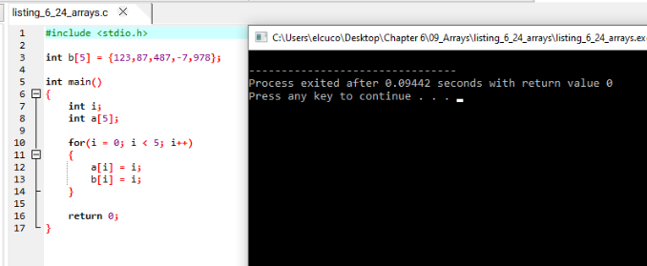The program runs silently because no output is printed.

What this means
The program creates:
- a global array named b
- a local array named a
The global array:
int b[5] = {123,87,487,-7,978};
is stored in global memory.
The local array:
int a[5]; is stored on the stack inside main().

The loop:
for(i = 0; i < 5; i++)
iterates from:
- 0
to:
- 4
Inside the loop:
- a[i] = i
- b[i] = i
This means each array element receives the current value of i.

What to Look for in IDA
Important instructions usually include:
mov
add
cmp
jmp
You should also look for:
- indexed memory access
- multiplication by element size
- base addresses

Explanation
The instruction:
mov [ebp+var_18], 0 initializes the loop counter i to 0.
The loop comparison:
cmp [ebp+var_18], 5 checks whether i is less than 5.

Local Array Access
The instruction:
mov [ebp+ecx*4+var_14], edx accesses the local array a.
This means:
- ebp+var_14 is the base address of array a
- ecx contains the index
- *4 scales the index because integers use 4 bytes
So: a[i] is accessed by: base address + (index × 4)

Global Array Access
The instruction:
mov dword_40A000[ecx*4], eax
accesses the global array b.
Here:
- dword_40A000 is the base address of array b
- ecx*4 calculates the correct array element offset
This directly accesses global memory.

Difference Between Local and Global Arrays
Array | Location | Assembly Style
a | Stack | [ebp+ecx*4+offset]
b | Global memory | dword_40A000[ecx*4]

Graph View Observation
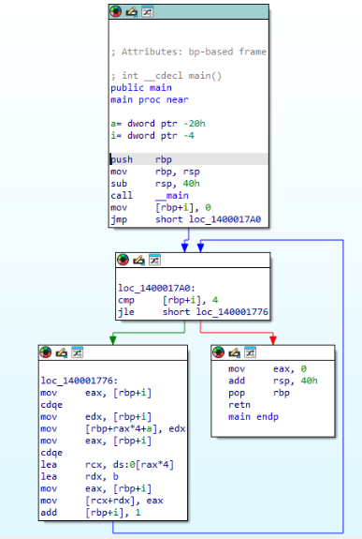

In graph view:
- the loop creates a circular execution path
- array operations occur inside the loop body
- indexed memory access appears repeatedly

This combination of:
- loops
- indexing
- memory offsets
is a strong indicator of array manipulation.

Your key point
The important observation is that arrays in assembly are accessed using:
- a base memory address
- an index
- scaled offsets
A reverse engineer can identify arrays by looking for indexed memory access patterns such as:
[ebp+ecx*4+offset] or: dword_40A000[ecx*4]
These patterns indicate that the program is accessing sequential memory locations as array elements.

Summary
This chapter demonstrated how common C programming constructs appear in assembly language after compilation.
The practical exercises introduced:
- Variable storage
- Arithmetic operations
- Conditional logic
- Loops
- Function calls
- Switch statements
- Arrays
- Graph analysis in IDA Pro
Understanding these assembly patterns is essential for:
- Reverse engineering
- Malware analysis
- Vulnerability research
- Low-level debugging
- Software analysis
By recognising these patterns, analysts can better understand program behaviour even when source code is unavailable.

